OVERALL PROGRAMME EVALUATION REPORT
SBVP ALUMNI MASTERCLASS - SCALE Module I Online Zambia (20th April 2026 - 24th April 2026)
No. of Respondents: 140
No. of Participants: 140
Response Rate: 100%
--------------------------------------------------

Faculty Reports

Benard Chege - Business Plan reviews
Evaluation Parameter | (%) Individual Score | (%) Programme Average
Punctuality (Commencement and Completion of Sessions) | 97 | 75
How well do you understand the core concepts presented? | 93 | 72
Rate your confidence in applying the new skills learnt | 87 | 72
Degree of Faculty preparedness for the sessions | 100 | 76
Content and methodology of the program | 97 | 77
Quality of class and group discussions | 90 | 72
The information presented in the course is relevant to my work (ministry) | 93 | 76
Average scores | 94 | 74

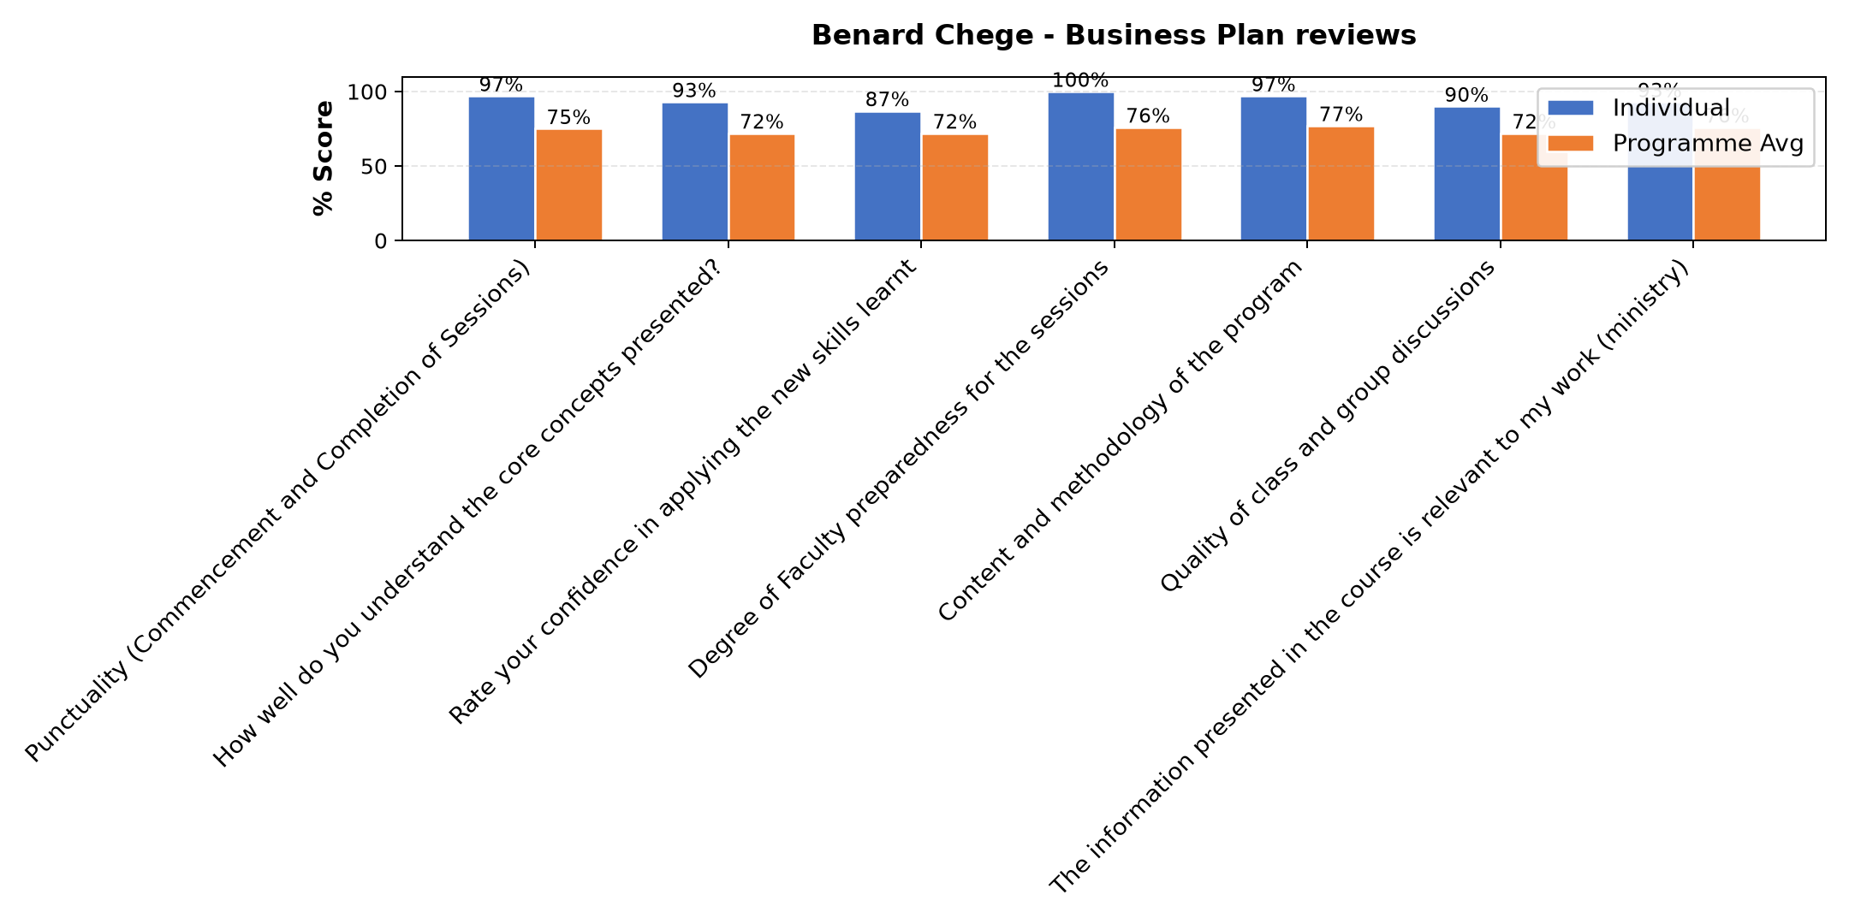

Comments & Feedback
- • The conclusion was abrupt
- • The lecturer had internet challenge and hence we could not reach the planned end time
- • Slow pace of implementation by contractors to build the hostels
- • Is just getting started turning the ideas into a written plan takes time we dont always have. All the same,the session gave me the tools,so I hope to apply them step by step with support from the team.

Dr. Nancy Nyambura Njiraini - Customers and Markets – what has changed?
Evaluation Parameter | (%) Individual Score | (%) Programme Average
Punctuality (Commencement and Completion of Sessions) | 100 | 75
How well do you understand the core concepts presented? | 92 | 72
Rate your confidence in applying the new skills learnt | 93 | 72
Degree of Faculty preparedness for the sessions | 95 | 76
Content and methodology of the program | 97 | 77
Quality of class and group discussions | 88 | 72
The information presented in the course is relevant to my work (ministry) | 97 | 76
Average scores | 95 | 74

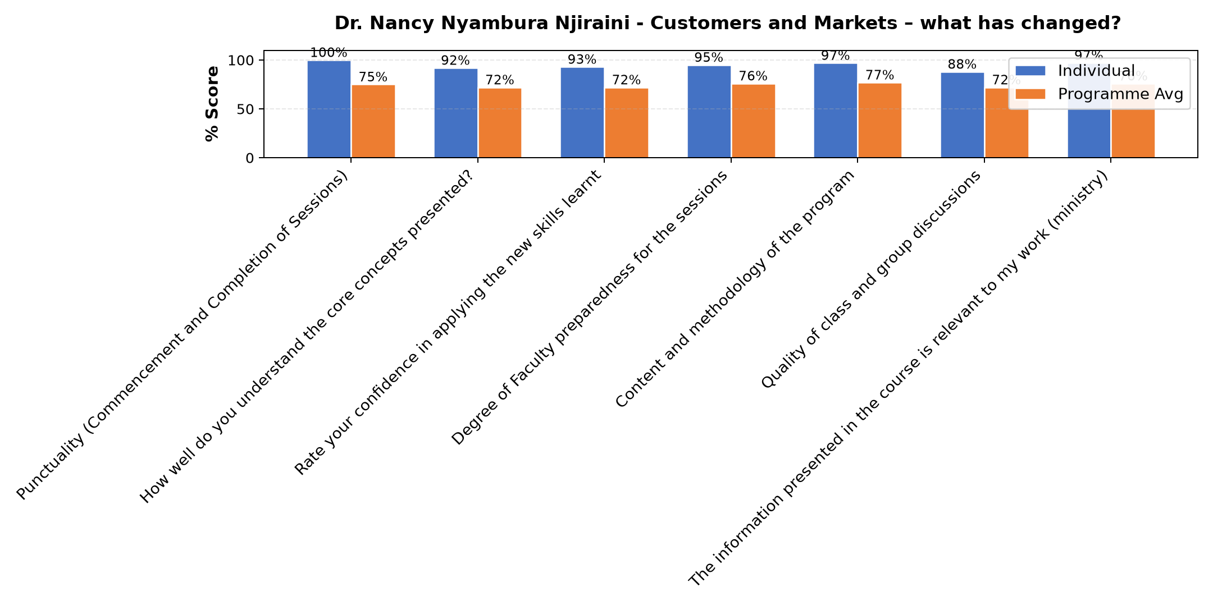

Comments & Feedback
- • Financial resources to help in boosting the project.
- • Inadequate resources.
- • Waiting for everything to be perfect is another barrier,but we can start by picking one small action instead of waiting.
- • Waiting for everything to be perfect is another barrier,but we can start by picking one small action instead of waiting.
- • Nothing, just need proper planning
- • lack of some equipments /Funds
- • Speaker was low , network problems
- • The audio system was straining to hear
- • The audio was straining hearing
- • No barrier will try the best
- • none yet
- • No barriers to prevent me so far

Lena Gachoki - Reflect on Vision and Mission
Evaluation Parameter | (%) Individual Score | (%) Programme Average
Punctuality (Commencement and Completion of Sessions) | 100 | 75
How well do you understand the core concepts presented? | 89 | 72
Rate your confidence in applying the new skills learnt | 88 | 72
Degree of Faculty preparedness for the sessions | 94 | 76
Content and methodology of the program | 95 | 77
Quality of class and group discussions | 91 | 72
The information presented in the course is relevant to my work (ministry) | 97 | 76
Average scores | 93 | 74

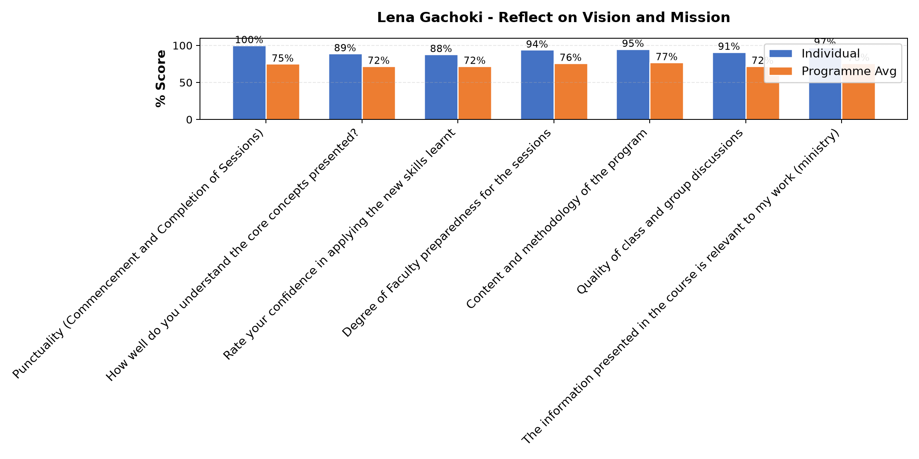

Comments & Feedback
- • Session was perfect
- • It was great
- • Change of perception especially on those I find difficult to work wolith
- • Lack of confident.
- • No barriers will prevent me from applying this rich information learnt today
- • Assertiveness
- • Understanding myself well enough
- • Great lesson

Benard Chege - Reflection of SEP Learning
Evaluation Parameter | (%) Individual Score | (%) Programme Average
Punctuality | 95 | 19
Clarity of presentation of concepts, course material, content and use of practical examples. | 92 | 18
Degree of preparation for the lessons | 83 | 17
Course design and organisation | 92 | 18
Content and methodology | 92 | 18
Quality of discussions | 83 | 17
The information presented was relevant to my work | 89 | 18
Average scores | 89 | 18

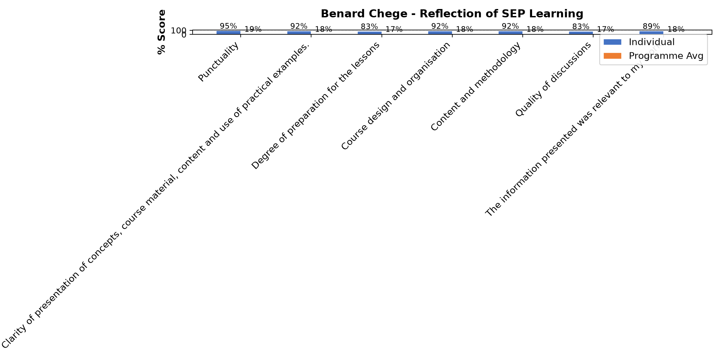

Comments & Feedback
- • Financial resources is the major barrier. The second burrier is to break the mind set of the beneficiaries
- • I am not on the ground of our project at the moment but can encourage from a distance
- • Finance
- • None for now
- • There are no barriers. The class today was very clear. I was able to follow the course with gratitude.
- • Donor dependency and fear of losing funding and lack of market data and pricing skill
- • Donor dependence
- • Depending on donors
- • Internet network
- • Working with my sisters whom we not share the same understanding
- • No barrier will prevent me
- • The barrier I am facing is I am not the one that make decision in the school where I am working.
- • Slowness of contractors to construct the hostel

Benard Chege - Reflection of SEP Learning
Evaluation Parameter | (%) Individual Score | (%) Programme Average
Punctuality (Commencement and Completion of Sessions) | 80 | 75
How well do you understand the core concepts presented? | 88 | 72
Rate your confidence in applying the new skills learnt | 90 | 72
Degree of Faculty preparedness for the sessions | 92 | 76
Content and methodology of the program | 95 | 77
Quality of class and group discussions | 92 | 72
The information presented in the course is relevant to my work (ministry) | 95 | 76
Average scores | 90 | 74

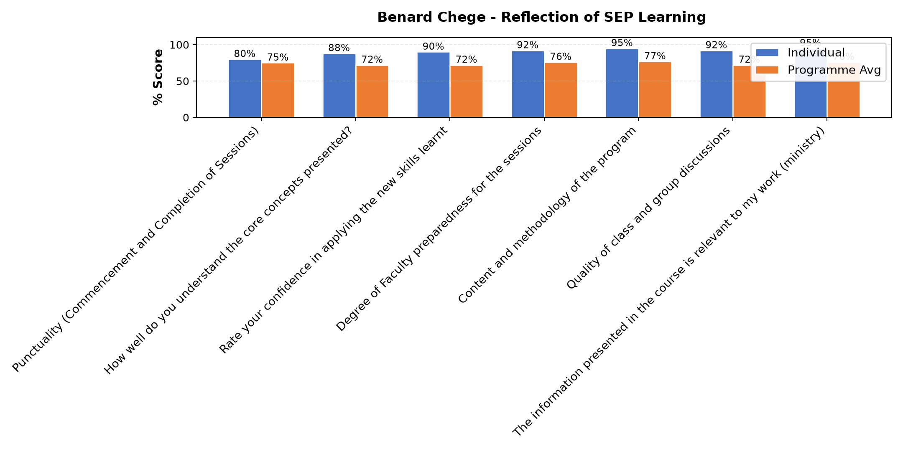

Comments & Feedback
- • Family members or neighbors dont believe social enterprises work, or dont think youths with disabilities can run a business and also you can make the product, but you dont know who will buy or how to reach them.
- • Capital resources like finances, vehicle and difficult of the beneficiaries to change their mind set
- • Family members or the community dont believe social enterprise work, or dont think youths with disabilities can run a business. You can also make a product, but you dont know who will buy or how to reach them.
- • Network and I cannot hear the teacher very well
- • I am currently not at the Social enterprise, but missioned outside the country. I will give support to the ones on the ground
- • Not sure if now
- • There are no barriers to prevent me. The sessions were very educative.

Department Reports

Are there any other comments and/or suggestions that you may want to add?

Comments & Feedback
- • Greatly appreciated
- • We are a master class, how can the congregations be supported financially especially where we are lacking
- • This is a good program but save some funds to help us boost our enterprises
- • Although time was limited, and a full day for the business plan session would have been better, I am still sincerely grateful to the sponsors,the team, the organisers, and all the facilitators. May God richly bless each one of you.
- • I am very grateful

General Comments

Comments & Feedback
- • This was well planned and delivered. Kindly give us the module before hand so that we can go through before the lesson.
- • Thank you very much it was a helpful session..
- • Thank you for helping me understand better what i have been hearing for a long time
- • Thank you very much for adding me
- • Sustainabi6for us means earning enough to protect dignity, starting with one short course
- • Our charism is clear therefore everything has to be clear as well.
- • We need to look for more different ways of raising money for sustainability
- • I like the input
- • The sharing for today was wonderful
- • The course is very good . The reflection help me to revise the lesson learnt in the last courses.
- • The reflections were helpful
- • The sessions that I have attended so far are powerful and eye- opening. I have learned how to find opportunities, and help others at the same time. May God help us to take these lessons and put them into action. Thank you very much.
- • This was very good opportunity for my congregations to use the skill and knowledge to creat more opportunities and be sustainable.
- • The sessions that i have attended so far are very powerful and an eye opener at the same time. I have learned how to find opportunities and help others at the same time. May God help us to take these lessons and put them into action. Thank you very much.
- • Thank you very much for today, It refreshed my mind
- • I am very grateful for this opportunity.
- • Thank you
- • Thank you the facilitator of the day.
- • Kindly help us with resource mobilisation to help in scaling up the project like you have done to some congregations.
- • I am grateful for the input , I have benefited alot.
- • The Marketing and Selling session was very practical. The biggest lesson I learned is that we must take action,even if it is small.
- • The Marketing and Selling session was very practical. The lesson that I have learnt today is that we must take action, even if it is small.
- • Thank you to Dr. the session was very practical and easy to understand
- • The presentation was enriching
- • The reflection was great
- • The reflection was good 👍
- • The session was great presented
- • I am very grateful
- • Well-done the facilitator of the day. It was such an interactive session of the day. God bless immensely.
- • Will do my part
- • My skill has been enriched
- • Self awareness is good and this time I understand it well being the second time.
- • The session was enriching and the facilitator was good so much that even if I missed few sessions I was able to follow and connect it according to my color temperament.
- • The session was empowering. Its great.
- • I benefited from the reflections
- • I didnt get most of the things because of network challenges. But I appreciate todays session. Thank you very much
- • Excellent presentation
- • Thank you for everything
- • I did not manage to fully participate the all time but the time I have about my colour strengths and weakness has/ will help me in knowing myself better and in my relations to others
- • I am grateful
- • More information gained
- • Will try to move on with our enterprise and embrace it
- • Wonderful sessions
- • Online lessons are good but it seems in Africa we are all facing the same challenge.
- • The reflection was very good
- • I had challenges with internet in todays session.The network was bad
- • Thank you very much for giving us these opportunities

Overall Evaluation
Evaluation Parameter | (%) Score
Overall program evaluation | 93
Average score | 93

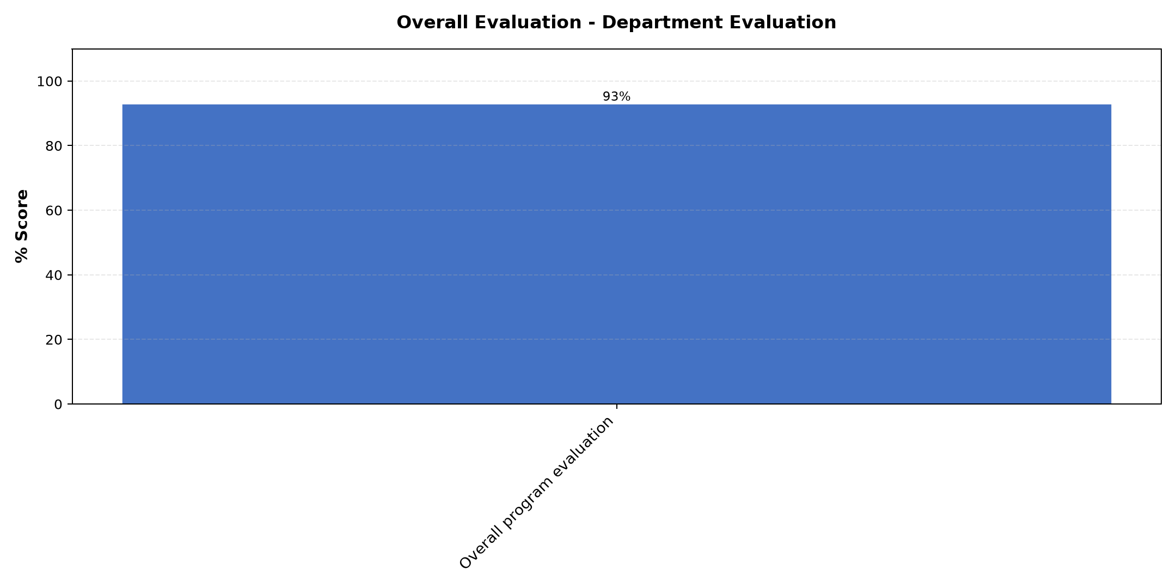

Comments & Feedback
No comments recorded.

Program Manager (Paul Bikundo)
Evaluation Parameter | (%) Score
Punctuality (Commencement and Completion of Sessions) | 100
How well do you understand the core concepts presented? | 97
Rate your confidence in applying the new skills learnt | 97
Degree of Faculty preparedness for the sessions | 100
Content and methodology of the program | 97
Average score | 98

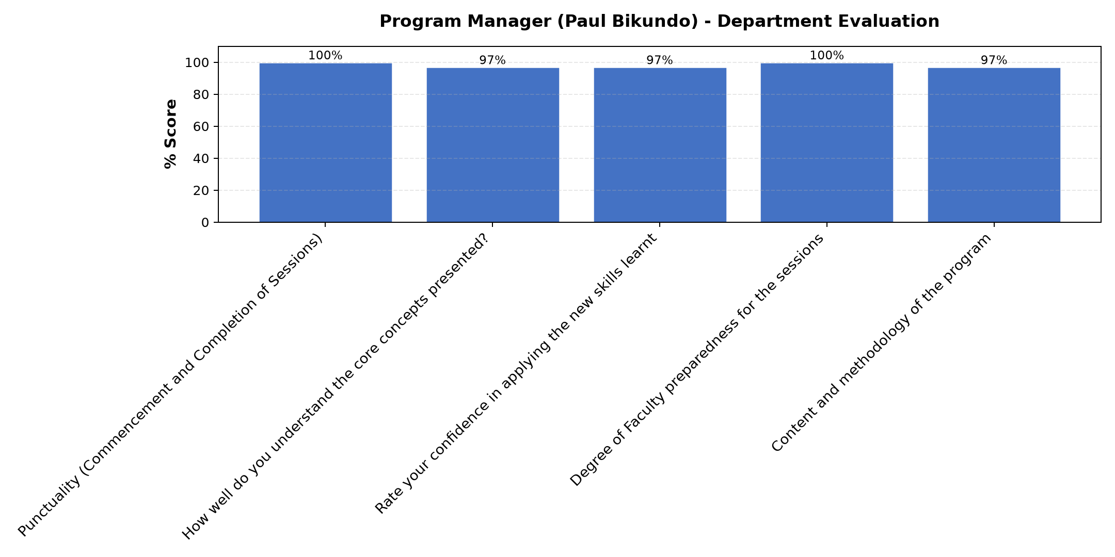

Comments & Feedback
- • Continue to put knowledge in us
- • He is a wonderful manager
- • The program was well run despite the internet challenges. When the lecturer/s lost network, the facilitator was proactive by standing in.
- • He is a good communicator
- • Overall, it was a worthwhile experience and thank you to everyone who made it possible.

What attracted you to the programme??

Comments & Feedback
- • Skill gained
- • Skills generated by SEP
- • the fact that the program is basing our business development on our Charism, vision and mission. It is helping us to be self-sustainable in both Congregation as well as capacity building our beneficiaries in different apostolates.
- • Reflection- as Socrates once said, "A non-reflected life is not worth living"
- • Is that the sessions were practical. The sessions didn't just give theory they showed us how to apply these ideas. They helped me to see how we can grow the centre and support our learners better and also the discussions were open and the examples related to the real challenges we face with our learners and income- generating activities.

What topic would you recommend being expanded/improved in this programme’s units?

Comments & Feedback
- • Finance
- • Leadership
- • Essence of leadership
- • Marketing and Business plan
- • How to manage accounts in our work area. What are the books we need and how do we keep accounts

Which areas in this programme did you find most important to your social enterprise?

Comments & Feedback
- • Marketing
- • All the topics dealt with were worthy
- • Reflections on SEP learning (Charism, vision, mission and objectives), Reflection on leadership and teams, Customer and marketing, perception and leadership, Review of business plan
- • All the areas were worthwhile
- • Social Enterprises,Marketing,Leadership and business plan

Which teaching methods applied in the course did you enjoy/learn from the most?

Comments & Feedback
- • Group discussion
- • Interactive group sharing and reflection
- • Group and class discussions where later I learnt a lot from presentations form different congregations
- • Sharing from different congregations and consolidation from presenters
- • I enjoyed almost all of them except today's session which was difficult to follow due to network.
- • The use of power point appeals to me

